OUR BOARD MEMBERS:
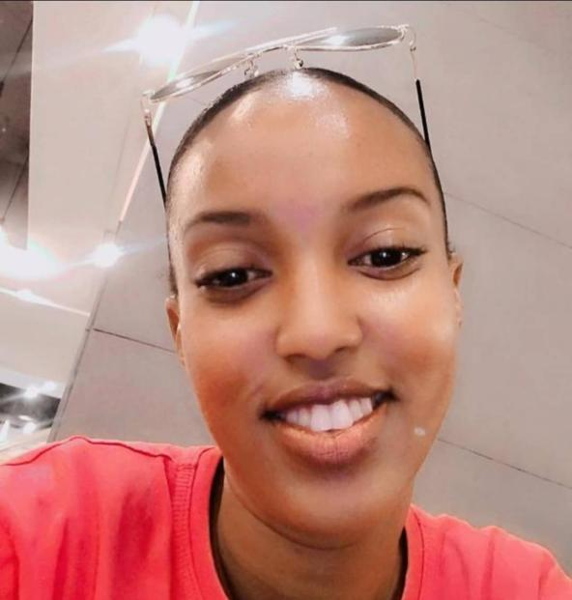
Chairperson: Princia KORONADO from Central African Republic

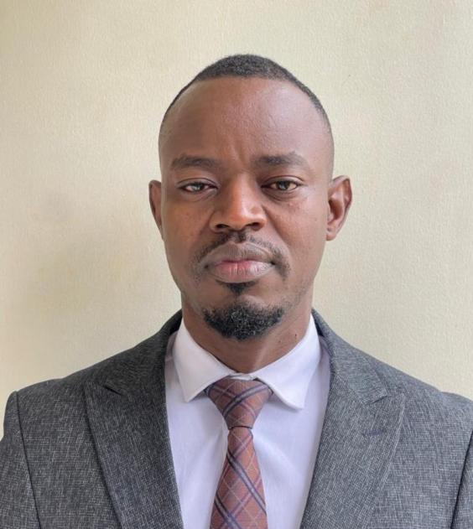
Vice-Chairperson: MUGABO Adelithe from Rwanda


Treasurer: Mr. Emmanuel ISHIMWE MAKOPORO from Republic Congo BrazaVille

Secretary:

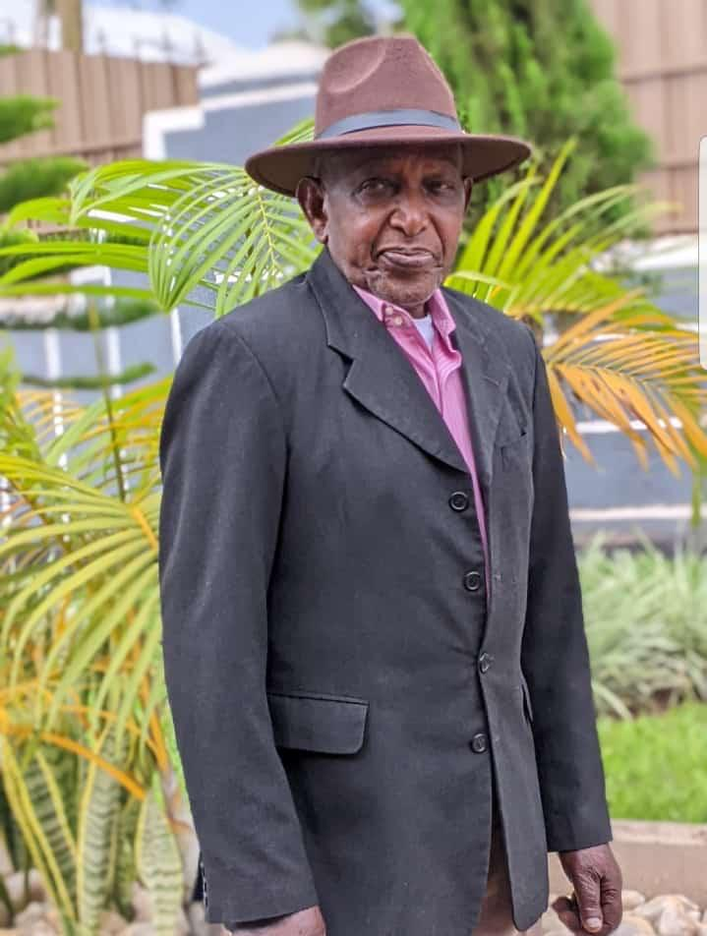
First Advisor: RWIKIMA FRODUARD from Eastern-DRC (North and South Kivu)

Second Advisor:

